**SEDIMENT BALANCE- BASIC CONCEPTS**

**AY 2017-2018**



***Cellini’s (1500-1571) Salt Cellar, Vienna, Kunsthistorisches Museum***

“the Land and the Sea, both sitting, with their legs intertwined, like some branches of the Sea enter the Earth and the Earth enters the Sea”

*Contents derive partly from*

[*https://en.wikipedia.org/wiki/Longshore_drift*](https://en.wikipedia.org/wiki/Longshore_drift) [*https://en.wikipedia.org/wiki/Sedimentary_budget*](https://en.wikipedia.org/wiki/Sedimentary_budget)

*https://en.wikipedia.org/wiki/Swash#Cross-shore_sediment_transport*

*and also from the course notes of Catania Enrico Foti and Rosaria Musumeci, University of Catania.*

*Textand formulas* marked in blue or grey are not part of the course program;

Parts *in italics are exercises to be carried out autonomously*

From: <https://en.wikipedia.org/wiki/Sedimentary_budget> (slightly modified )



**Sedimentary budgets** is used to analyze and describe the different sediment inputs (sources) and outputs (sinks) on the coasts; Its main objective is to assess and if possible predict morphological change in any particular coastline over time.

Within a coastal environment the rate of change of [sediment](https://en.wikipedia.org/wiki/Sediment) is dependent on the amount of sediment brought into the system versus the amount of sediment that leaves the system. These inputs and outputs of sediment then equate to the total balance of the system and more than often reflect the amounts of [erosion](https://en.wikipedia.org/wiki/Erosion) or [accretion](https://en.wikipedia.org/wiki/Accretion_(coastal_management)) affecting the morphology of the coast.[[1]](https://en.wikipedia.org/wiki/Sedimentary_budget#cite_note-1)[[2]](https://en.wikipedia.org/wiki/Sedimentary_budget#cite_note-ref1-2)

To assess the sedimentary budget the coast has to be divided into two separate morphologies, commonly known as ***littoral cells*** and compartments. Such **sediment cells** can usually be defined by natural barriers such as rocky headlands or artificial barriers such as groyns or piers, which mark the ends of a beach and stop – up to a point – sediment from moving out of the cell.

Littoral cells can either be free or fixed and can occupy a hierarchy of scales, from individual rip cells to entire beaches

A gulf is typically a sediment cell :

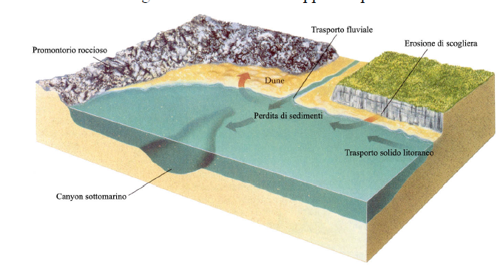

The concept of cell is not absolute, because more often than not the barriers are not completely tight. Part of the sediment can move along the coast and bypass the obstacles – especially if the bottom is not too deep (see later :“active depth”). So one can define “subcells”

Various examples: Bays of Salerno, Naples, Gaeta are easy to define; Gaeta, though, can be also easily subdivided into two subcells. Near the mouth of the Alento river; Calabrian Tyrrenian coast, originally probably could be considered a single cell from the Noce river to Falerna, but now divided into subcells by the various man made obstacles. *Identify all these features on Google Earth* and try and immagine a division into subcells*. Make use of the closure depth concept*

Identifying littoral cells is crucial to determine the sediment budget of sandy coasts

A particular kind of cell are the so called “pocket beaches”; they are very small, and the sand is trapped between the two headland on their sides.

There are three kinds of boundaries in a littoral cell: longshore, landward, and seaward; across which sediment may enter the littoral cell or leave it by various processes: the landward boundary of a littoral cell is usually the foot of a dune or a cliff, or an artificial obstacle such as a wall or road,

The seaward boundary is difficult to define exactly, since the mechanisms of cross shore [sediment transport](https://en.wikipedia.org/wiki/Sediment_transport)  are poorly understood. There is however an useful concept: the closure depth (see):I

It is important to identify which processes operate on a particular littoral cell and also important to identify sediment sources and sinks,

There are various types of natural sources and sinks within a coastal system. Sediment sources can include **river sedeiment input and**  **sea cliff erosion**

Sediment sinks can include cross-shore losses (often submarine canyons, estuaries), trapping of sediment by coastal structures or natural morphology, longshore drift of sediment away around supposedly sediment cell limits

Anthropogenic activities can also influence sedimentary budgets; in particular damming of a river and gravel mining of river bed or beaches can reduce the sediment source to the coast.

[Beach nourishment](https://en.wikipedia.org/wiki/Beach_nourishment) can increase the sediment sources.

Sedimentary budgets are used to assist in the management of beach erosion by trying to show the present sediment movement and forecast future sediment movement.

The movement of sediment within a cell is one of the most important aspects of coastal balance.

Sediment transport can be conveniently classified into:

Cross shore transport

Long shore transport (drift)

The terms are self explaining, and the following pictures help clarify the concepts. It should be however be kept in mind

Both are caused by the wave action, and obviously they are closely connected.

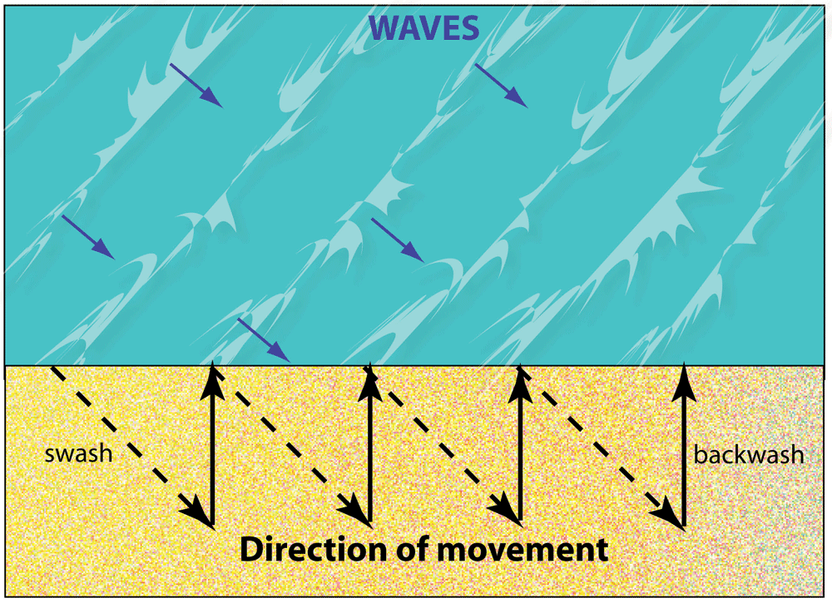

Short term variations of a beach profile are due to sediment transport both along the shoreline (longshore transport) and in the direction normal to the coast (cross-shore transport). It is often observed that sea storms cause loss of sediments (erosion); it is less immediately evident, that weaker sea states help reconstruct the profile. The shoreline nearly always increases in the summer due this accretion process.

When working on an intermediate time scale (one to a few years) it is often assumed, that cross-shore erosion balances accretion- so that the variation of the shoreline derive only from longshore transport. When an even longer time scale is considered, this hypothesis is of course unsustainable.

**SEDIMENT CELL_ SEDIMENT BUDGET**

Sediment budget is the application of the conservation principle to the mass of coastal sediments: the difference between the input and the loss of sand. The real problem lies in understanding and estimating the quantities involved. This can be done with various time scales: a single storm; a season, a year, or many years

|  |  |
| --- | --- |
| **INPUT** | **LOSSES** |
| **Long shore transport (through “leaky” barriers)** | **Long shore transport (through “leaky” barriers)** |
| **River inputs** | **Underwater Canyons, ditches** |
| **Artificial beach nourishment** | **Sand or gravel mining** |
| **Cliff erosion** |  |
|  |  |

An example of erosion study : near the mouth of the Sele River- 1954-2001

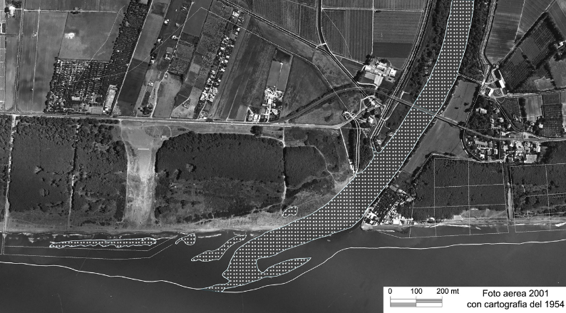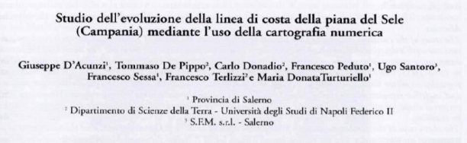

This is what happens near an artificial or natural obstacle when there is a longshore transport

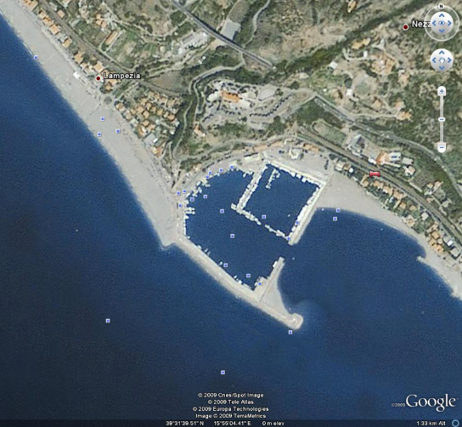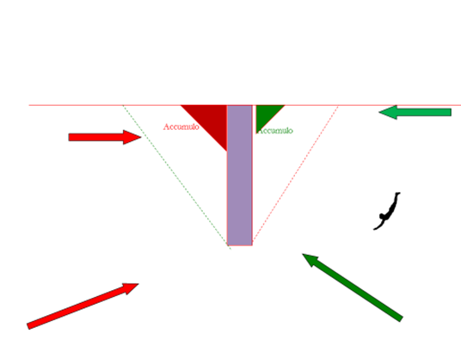

Sediment are trapped: when the direction of the sediment drift is towards the obstacle (e.g., red) , the sediment pile up; when the storm is in the opposite direction (e.g. green) they are sheltered and do not move. This often causes the formation of a beach. The effect often takes places on both sides, but it is generally asymmetrical: much bigger storage on one side, since there is one prevailing direction of the sediment drift, red in the pictures

The obstacle may also cause the deviation of the flux towards the open sea and therefore often the final loss of sediment

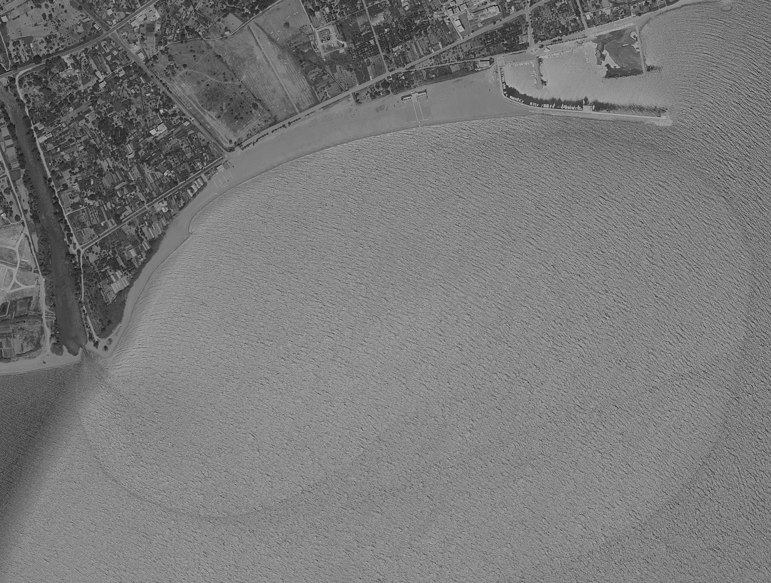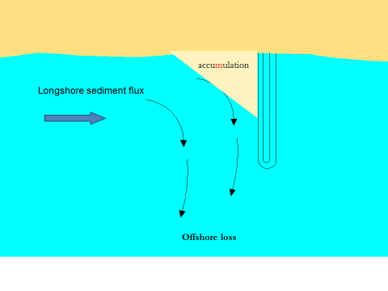

This latter aspect can be reduced by properly designing the piers or the groins

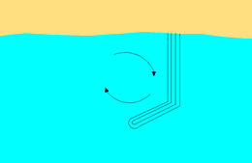

**Beach nourishment**

* https://en.wikipedia.org/wiki/Beach_nourishment

[Sediment](https://en.wikipedia.org/wiki/Sediment)  lost through [longshore drift](https://en.wikipedia.org/wiki/Longshore_drift) or [erosion](https://en.wikipedia.org/wiki/Erosion) is replaced from other sources. A wider beach can reduce storm damage to coastal structures by dissipating energy across the [surf zone](https://en.wikipedia.org/wiki/Surf_zone), protecting upland structures and [infrastructure](https://en.wikipedia.org/wiki/Infrastructure).

**A Glossary**

Adapted from http://www.mass.gov/eea/docs/dep/water/resources/a-thru-m/bchbod.pdf

Accretion - the gradual addition of land by deposition of water-borne sediment.

Beach Fill – also called “artificial nourishment”, “beach nourishment”, “replenishment”, and “restoration,” comprises the

placement of sediment within the nearshore sediment transport system

Beach Profile – the cross-sectional shape of a beach plotted perpendicular to the shoreline.

Cross-Shore Response – changes to the beach profile caused by the onshore and offshore movement of sediment after nourishment has taken place. It is the process by which a beach’s natural equilibrium profile is reached.

Depth of Closure – the seaward limit of sediment transport due to seasonal beach profile changes such as those caused by erosion and accretion.

Downdrift – the alongshore direction coincident with the sediment transport direction

Equilibrium Beach Profile – average (abstract) shape of the cross- shore beach profile

Fall Velocity – the maximum speed attained by a falling particle under the action of gravity in water (in other words, the terminal velocity).

Foreshore Beach – the intertidal portion of the beach. The foreshore, also

called the *intertidal* or *littoral zone*, is that part of a beach that is exposed

at low tides and submerged at high tidesHot Spot or Erosional Hot Spot – area along a shoreline where coastal

erosion is significantly greater than adjacent areas.

Erosional hot spotscan occur as a result of nonuniform wave conditions along the shoreline

(e.g., offshore shoals redirecting wav e energy), nonuniform sediment sizes along the shoreline, and sediment transport into a nearshore

excavated area.

Isolines - term for any graph or map on which some variable feature is constant. E.g isobaths .

Lag Deposit – deposit consisting of coarser sediment (generally pebbles, cobbles, and boulders) that remains on a beach after finer particles are transported downdrift by waves, winds and currents. Lag deposits are usually more resistant to erosion than sand beaches.

Littoral Zone – the area of beach that lies between the high water line and the depth of closure. The littoral zone is where a majority of sediment transport processes occur along the shoreline. Also known as the foreshore beach ~~and intertidal zone.~~

Longshore Transport – the amount of sediment moved along the coast through the combined effect of waves and

currents.

Subaerial Beach – the entire upper portion of a beach that is not under water at low tide.